Biological Sampling  - Crane surveys  - Southwestern willow flycatcher surveys  - Fish Sampling  - Snake Sampling | Animal Handling  - Venomous reptiles  - Live animal captures  - Livestock Inspections  - Animal safety | Pictures of local environment  Wildlife  ORV vehicles  Students working outdoors | Colorado River Indian Tribes  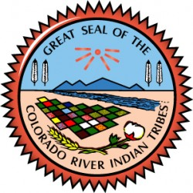  Department of Fish and Game
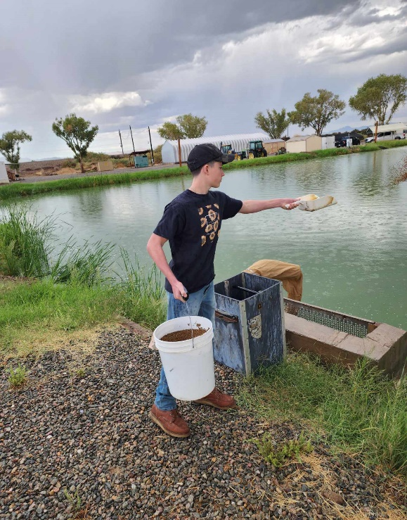 | Ride along with Wardens in Patrol Trucks  Work alongside Chief Game Warden Sharp  Learn how to operate warden equipment—radio, lights and more!  Application Deadline June 21st by 5pm! | 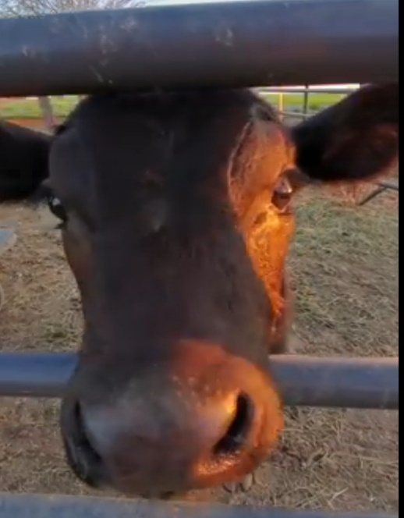 | Jr. Warden Program 2024  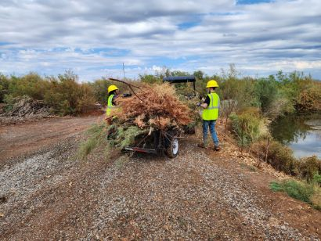
2100 Mutahar

•••
Parker, AZ 85344

•••
(928) 669-9285
•••

CRIT Fish and Game are recruiting 2 - 3 students to participate in the 2024 junior warden program. The program is designed to allow students to gain valuable real-life experience in wildlife and natural resources career field. | Do you enjoy being outdoors?  Do you enjoy learning about local wildlife?  Do you want to protect our ecosystem and land? | Fill out an application today to schedule an interview!  Send them to CRIT Fish and Game at  2100 Mutahar St. Parker AZ, 85344
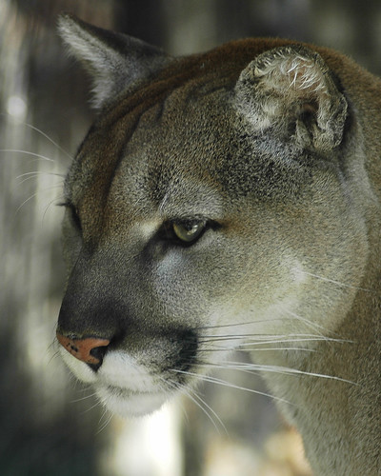 | A typical day for a junior warden  - Conducting surveys on local fish and wildlife  - Working directly with animals  - Writing Incident Reports  - Maintaining Trails and Clearing Overgrowth  - Ride with game wardens | 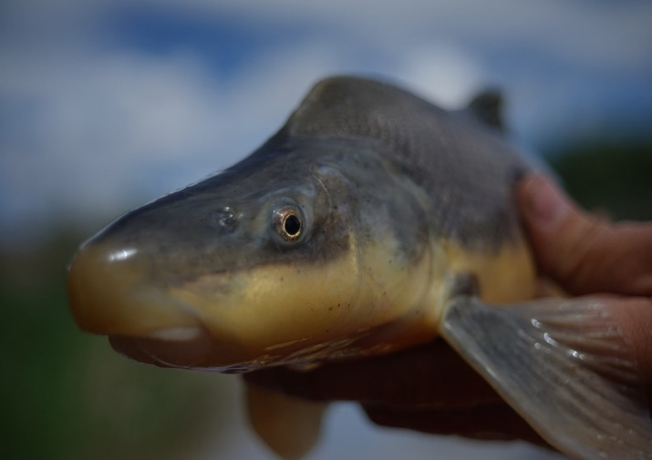 |  | Work alongside your fellow classmates
 | 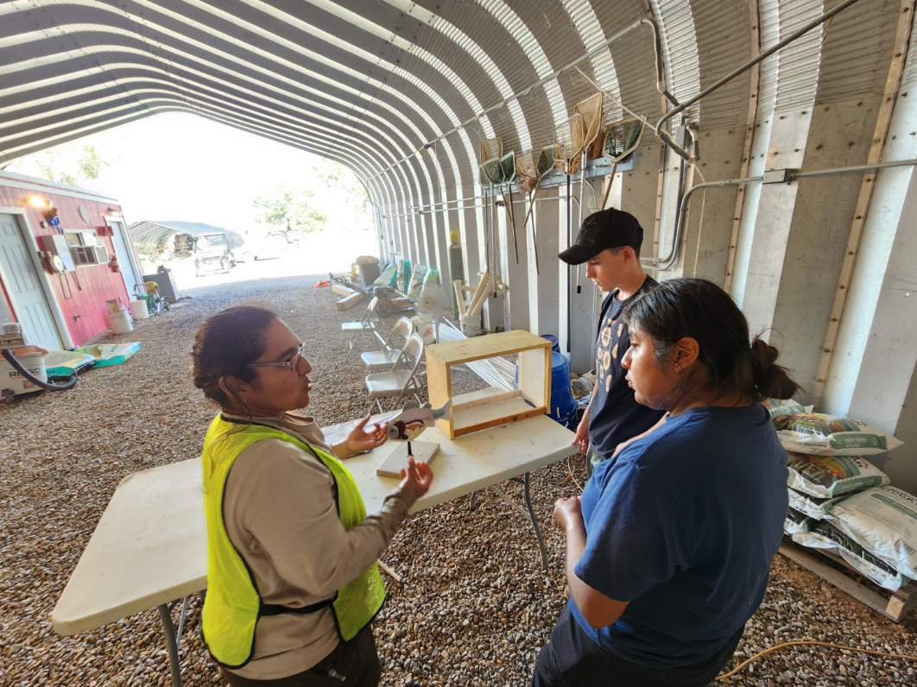 |  | Benefits  - Paid work  - Uniform provided  - Real life experience  - Future hiring preference at CRIT F&G  - Work Outside  - Networking opportunities | 